Chapter-Wise Crash Course: Angular

Chapter 1: Introduction to Angular
Time: 15 minutes
- ﻿﻿﻿What is Angular?
- ﻿﻿﻿Prerequisites
- ﻿﻿﻿Installing Angular CLI and setting up a new project:
- ﻿﻿npm install -g @angular/cli
- ﻿﻿ng new angular-app
4. Running the Angular app:
• ng serve
5. Overview of the project structure.
Chapter 2: Angular Core Concepts
Time: 20 minutes
1. Components:
- ﻿﻿Role of components in Angular.
- ﻿﻿Creating components (ng generate component).
- ﻿﻿Component decorators (Component).
- ﻿﻿﻿Modules: Introduction to AppModule.
- ﻿﻿﻿Template, Styles, and Class connection.
- ﻿﻿﻿Hands-on: Create and display a simple component with data binding.
Chapter 3: Data Binding and Directives
Time: 30 minutes
1. Data Binding:
• Interpolation ({{ }}), Property binding ([property]), Event binding ((event)), and Two-way binding ([ (ngModel) ]).
2. Directives:
- ﻿﻿Structural Directives: @if, @for,@ngSwitch
- ﻿﻿Attribute Directives: ngStyle, ngClass.
3. Hands-on Example:
• Display a list using @for.
Show/hide a section using @if.

Chapter 4: Services and Dependency Injection|
Time: 20 minutes
- ﻿﻿﻿What are services?
- ﻿﻿﻿Creating a service (ng generate service).
- ﻿﻿﻿Injecting the service into a component.
- ﻿﻿﻿Sharing data across components using services.
- ﻿﻿﻿Hands-on Example: Fetch data in one component and share it with another.
Chapter 5: Routing and Navigation
Time: 30 minutes
- ﻿﻿﻿Setting up routing: Import RouterModule.
- ﻿﻿﻿Configuring routes: Define paths in app. route.ts.
- ﻿﻿﻿Using routerLink, routerLinkActive and router-outlet.
- ﻿﻿﻿Route parameters (ActivatedRoute) and passing data in routes.
- ﻿﻿﻿Hands-on Example: Create two components and navigate between them with routes.

Chapter 6: Forms in Angular
Time: 30 minutes
1. Template-Driven Forms:
- ﻿﻿Binding inputs using FormsModule.
- ﻿﻿Adding simple validations (required, minlength).
2. Reactive Forms:
- ﻿﻿Introduction to FormGroup and FormControl.
- ﻿﻿.
Adding programmatic validation.
3. Hands-on Example: Create a login form using both approaches.
Chapter 7: HTTP Client and APls
Time: 25 minutes
- ﻿﻿﻿In Memory Web Api (for Mock Api)
- ﻿﻿﻿Importing HttpClientModule.
- ﻿﻿﻿Performing GET, POST DELETE and UPDATE requests with HttpClient.
- ﻿﻿﻿Handling API responses.
- ﻿﻿﻿Hands-on Example: Fetch and display data from a public API (e.g.,
JSONPlaceholder).

Angular = TypeScript + JavaScript + HTML + CSS

Single Page - App will have a single index.html.Data will be added and deleted there.
Component - Building block of angular app.
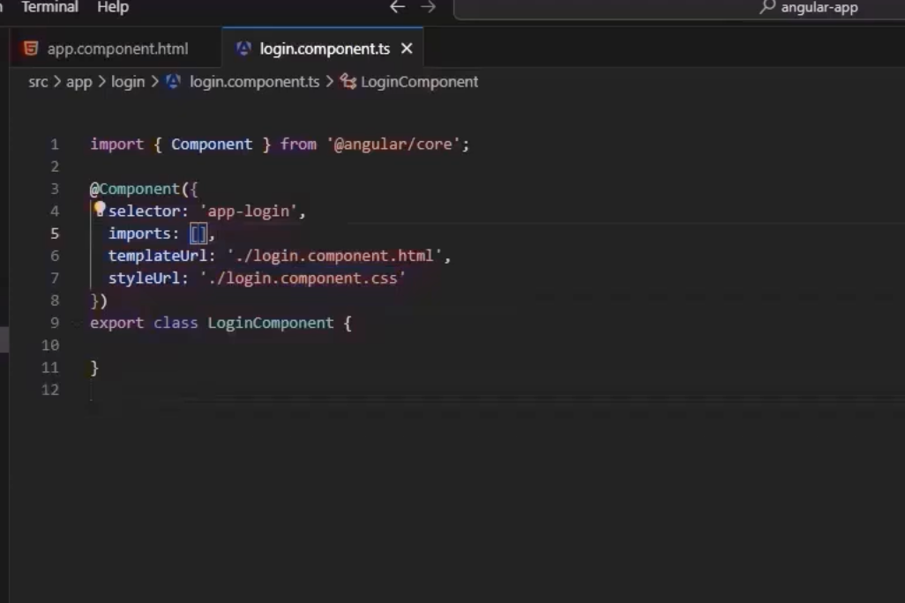

# Create app
ng new my-app

# Go inside app
cd my-app

# Create module
ng g m auth

# Create component inside module
ng g c auth/login

# Run project
ng serve

This is a simple class without @component decorator.
But with @component decorator it is component.

@Component({
This is called Metadata.
})

Module - It is like a container that groups related parts of the app.Such as components.

Whenever we create a component - It will be by default created as standalone.
We have to set standalone = false. To add it in a module.

A module is like a container where we keep our service and directive or group together.

@NgModule({
declarations: [RegisterComponent],
imports: [CommonModule]
})
export class AuthModule { }

Components must be declared in a module because Angular does not detect them by folder; it only recognizes components that are registered in the module’s declarations metadata.

An NgModule is a container that groups related pieces of your app (components, directives, pipes, services) into a cohesive block.

Chapter 3: Data Binding and Directives

From Databinding –

Data Binding in Angular is the process of connecting data between the component (TypeScript) and the template (HTML).

Types of Data Binding (Very Short)
- Interpolation → {{ data }} (TS → HTML)
- Property Binding → [property]="data" (TS → HTML)
- Event Binding → (click)="function()" (HTML → TS)
- Two-way Binding → [(ngModel)]="data" (Both ways)

Data binding is a technique in Angular that allows automatic synchronization of data between the component and the view (template).

1️⃣ Interpolation {{ data }}

📌 Definition:
Interpolation is a one-way data binding that displays data from the TypeScript (component) to the HTML (template) using {{ }}.

🔁 Direction:
TS → HTML

export class App {
title = 'angular-app';
myname = 'ritesh';
num1 : number = 10;
num2 : number = 20;

get sum() : number {
return this.num1+this.num2;
}

}

<h2>Interpolation</h2>

{{title}}
{{myname}}

<p>The sum of{{ num1}} and {{num2}} is {{sum}}</p>

- Get sum() == sum () :number {//without get and in html sum() }

- Use this. when accessing variables or methods that belong to the class (component).
Because inside a method, TypeScript does NOT automatically assume class properties.
You must explicitly say:
this.num1;
this.num2;

2️⃣ Property Binding [property]="data"

📌 Definition:
Property binding is used to bind a value from your component (TypeScript) to an HTML element property.

🔁 Direction:
TS → HTML
export class App {
title = 'angular-app';
myname = 'ritesh';
num1 : number = 10;
num2 : number = 20;

get sum() : number {
return this.num1+this.num2;
}

username: string = 'Rahul';

}

<h2>Interpolation</h2>

{{title}}
{{myname}}

<p>The sum of{{ num1}} and {{num2}} is {{sum}}</p>

<h2>Property Binding</h2>

<input [value]="username">

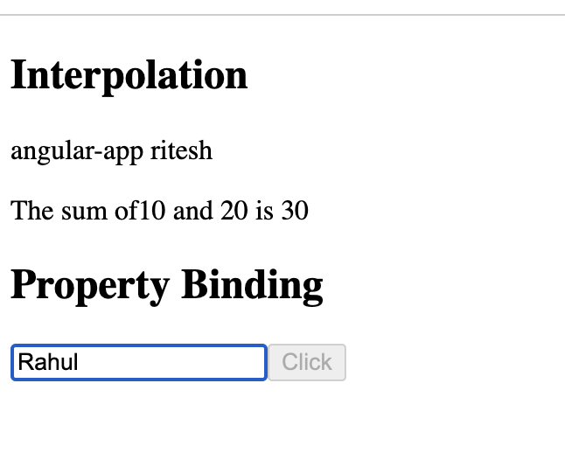

Used for DOM properties like:

- value
- src
- disabled
- checked
- href

3️⃣ Event Binding (event)="function()"

📌 Definition:
Event binding is used to send data from the HTML (view) → TypeScript (component) when an event happens (like click, input, change, etc.).

🔁 Direction:
HTML → TS

Why use event binding?
Because it lets your component react to user actions like:
- Click
- Typing
- Mouse events
- Form submission
//Event Binding
showMessage() {
console.log('Button clicked');
}

<h2>Event Binding</h2>

<button (click)="showMessage()">Click me</button>

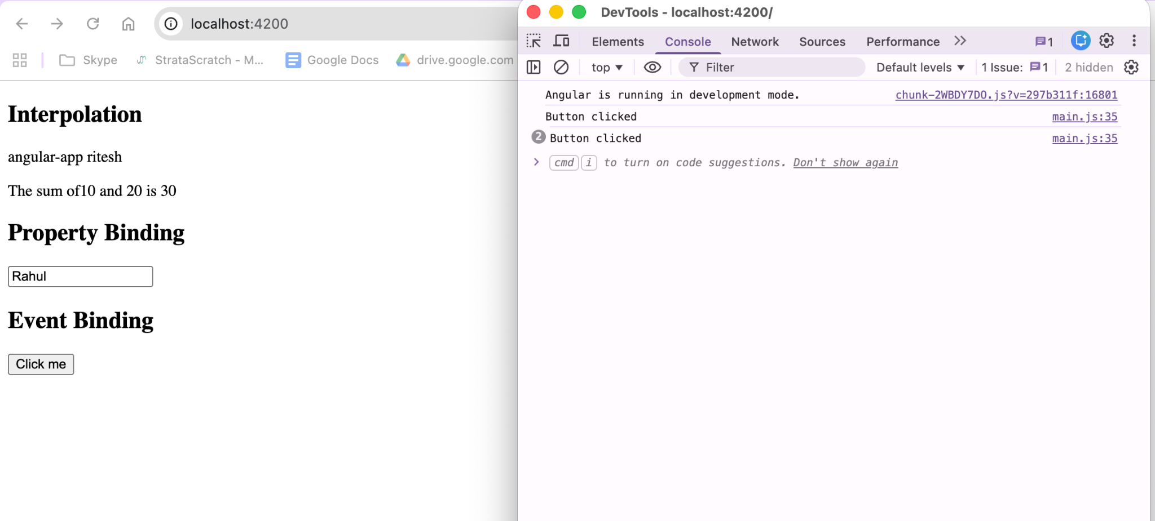

4️⃣ Two-Way Binding [(ngModel)]="data"

📌 Definition:
Two-way binding automatically synchronizes data between the component and the UI in both directions.

🔁 Direction:
TS ⇄ HTML (Both ways)
[ ] → Property → TS ➝ HTML
( ) → Event → HTML ➝ TS
[( )] → Two-Way → TS ⇄ HTML

Directives -
Directives are classes in angular that let you add custom behaviour to elements in DOM.(like changing style and handling events).

There are 3 types of directives -

1.Component Directives -
A directive with a template (basically a component).
When we use another component’s selector and place it in another component that is called component directives.

2. Structural Directive (*ngIf)
Changes DOM structure (add/remove elements).
If else ka use krke dom elements remove and add kr skte hain.

isLoggedIn : boolean = true;

<h2> Structural directive </h2>

<!-- Structural directive -->

@if(isLoggedIn){
<p>You are logged in</p>
<p>Welcome User</p>
}
@else{
<p>Please Login</p>
}

3.Attribute Directive
Changes appearance/behavior of an element.

import { Directive, ElementRef } from '@angular/core';

@Directive({
selector: '[appBlue]'
})
export class BlueDirective {
constructor(private el: ElementRef) {
this.el.nativeElement.style.color = 'blue';
}
}

<h2> Attribute directive </h2>

<!-- Attribute directive -->

<p appBlue>This text will be blue</p>

OR

imports: [FormsModule , BlueDirective , CommonModule], // ✅ Add FormsModule here
// imports: [CommonModule], // ✅ Required for ngClass, ngIf, ngFor, @for, etc.

isActive : boolean = true;

.active {
background-color: green;
}

<p [ngClass]="{'active': isActive}">This is paragraph</p>

ngClass, ngIf, ngFor are built-in attribute/structural directives
They are provided by CommonModule
Without importing it, Angular doesn’t recognize [ngClass]

Chapter 4: Services and Dependency Injection|

Service in Angular :
A service is a class used to share reusable logic, data, or functions across multiple components using Dependency Injection.

Created data service -
ng generate service data

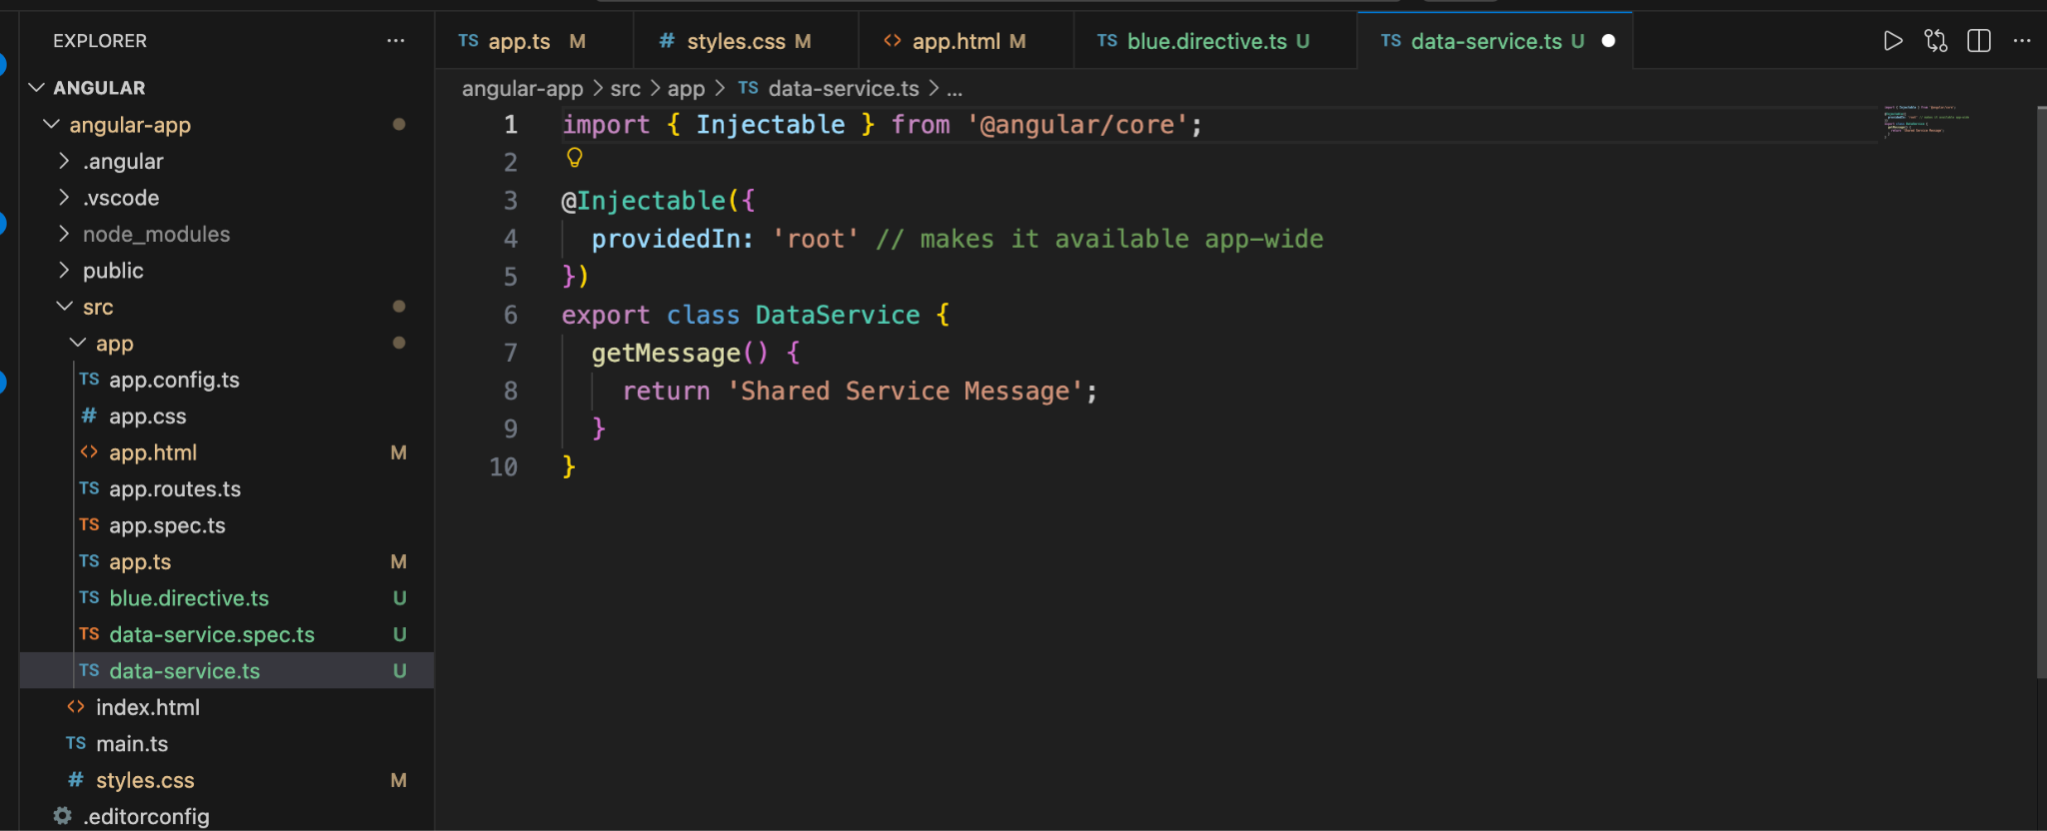

@Injectable() = Marks a class as available to be injected into components, directives, or other services.

